Portfolio Website Design

**Site Goal:** This site will serve as my portfolio and resume. It will include information about myself and my interests, as well as my skills and awards.

**Audience:** This will be available to potential employers and professors so they can better know my qualifications and me.

**Desktop and Phone Wireframe:** Here is an Idea of what the website will look like on each page.

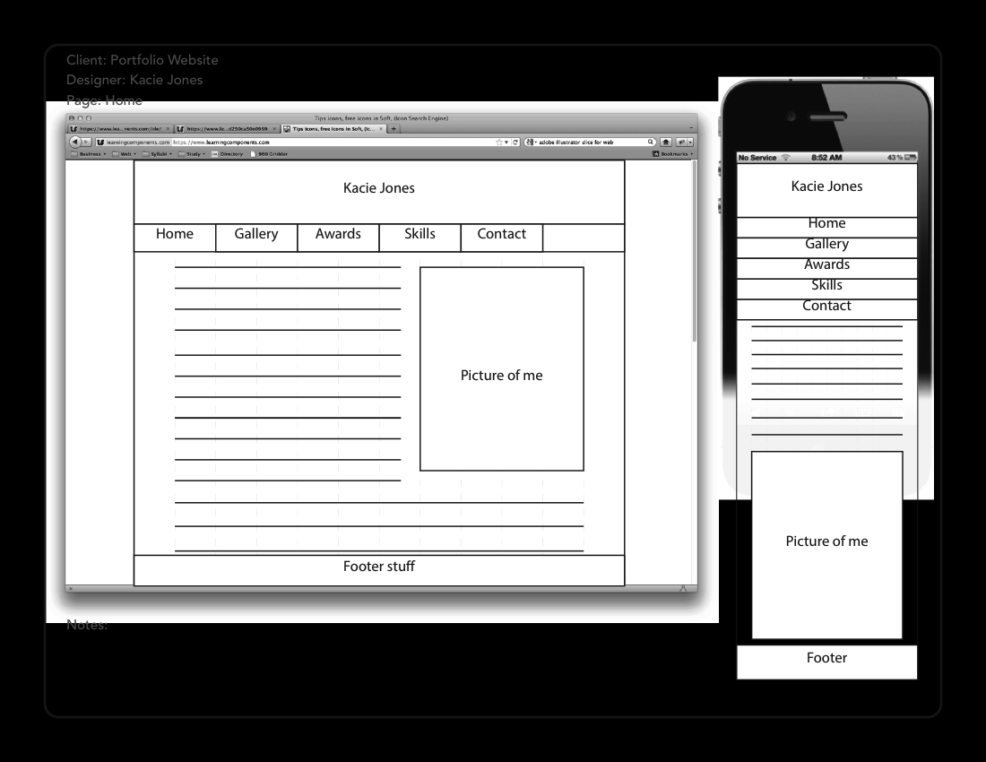

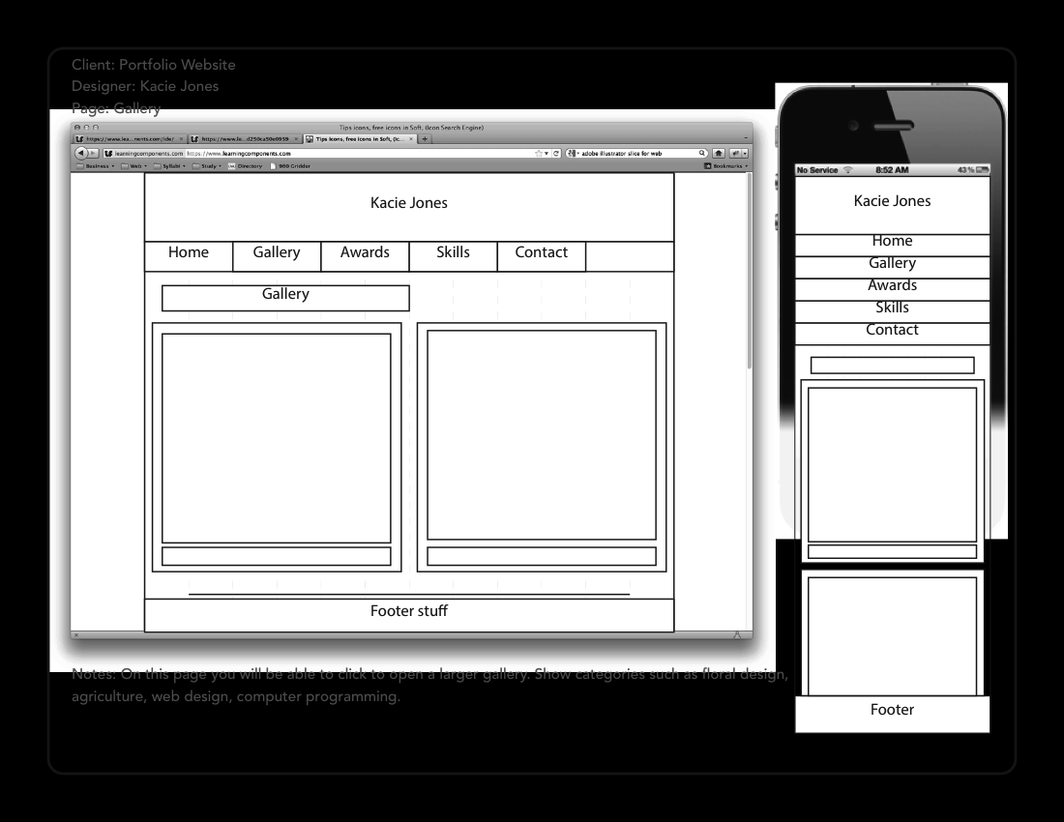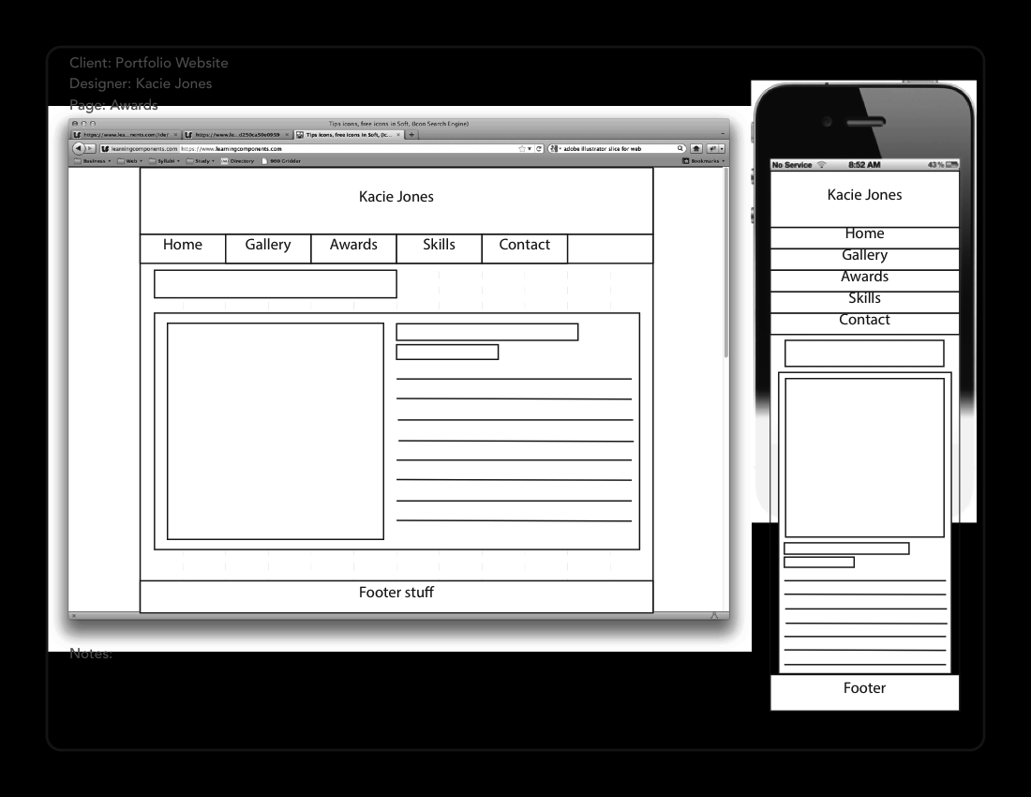

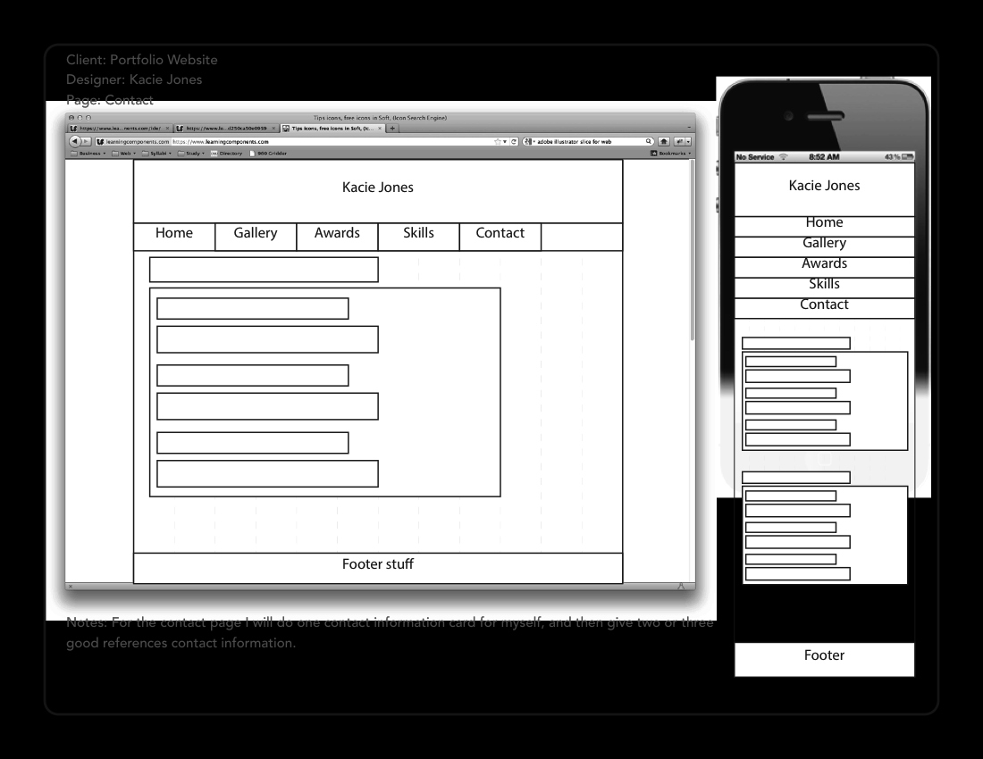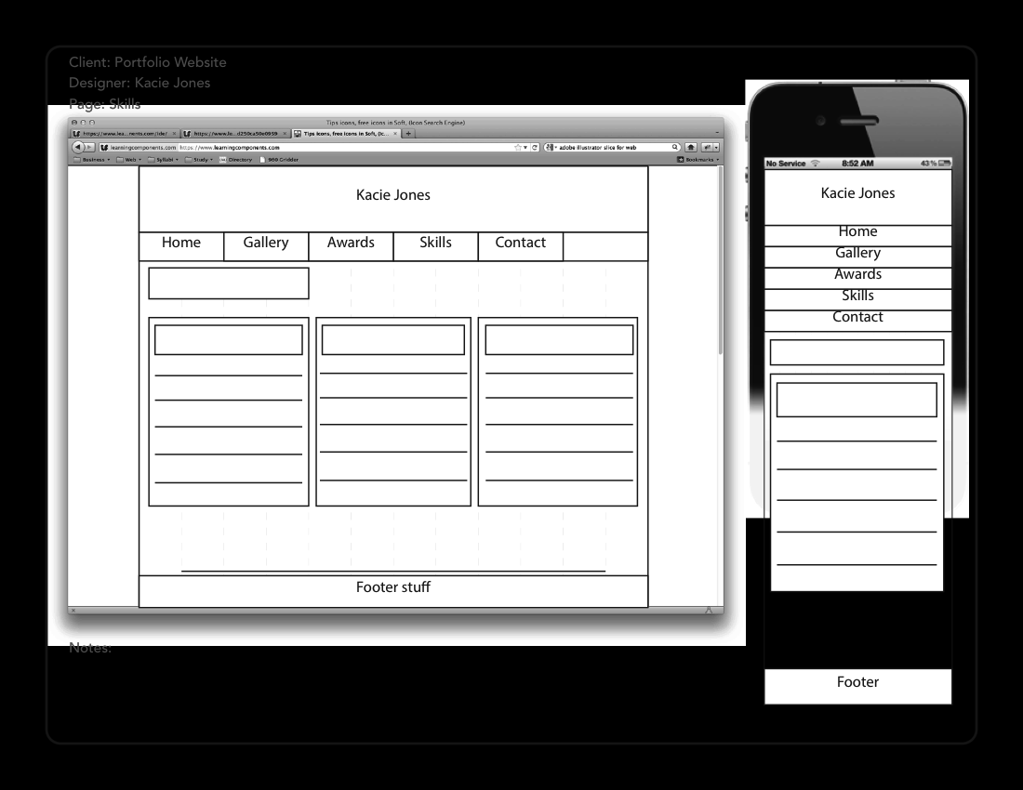

**Site Map:** All of the pages will be accessible from the navigation bar. Possibly on the gallery I will have folders that you can click on an it will open a gallery that relates to that topic.

About/ Home

Gallery

Awards

Skills

Contact

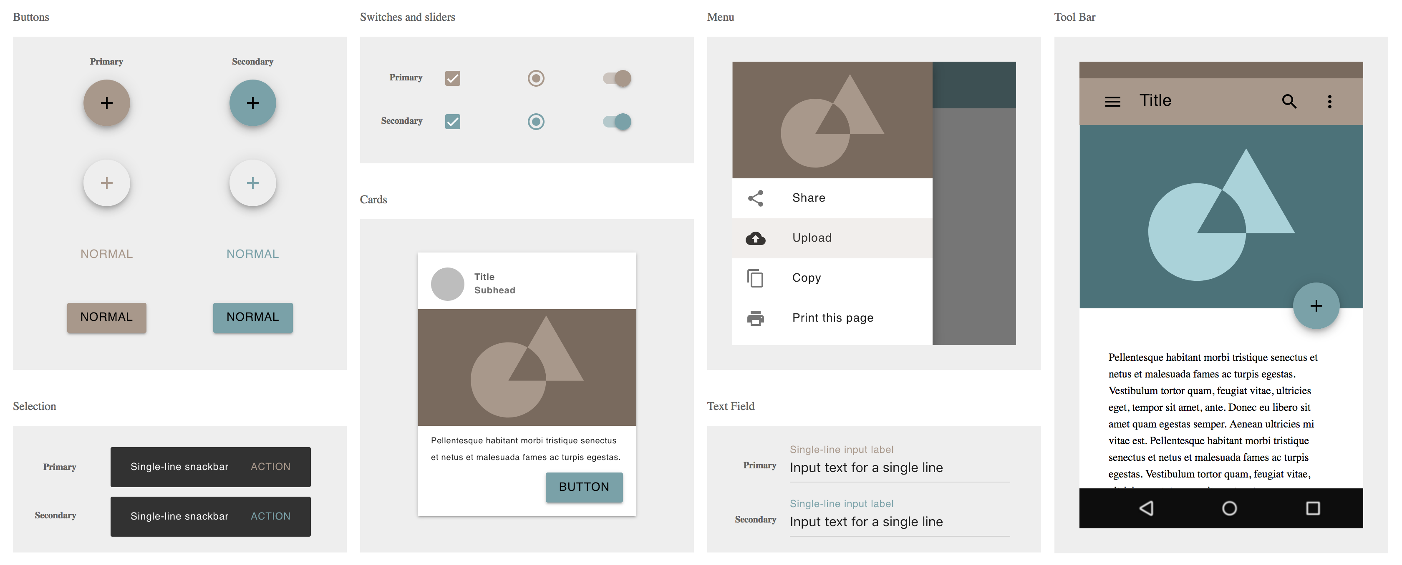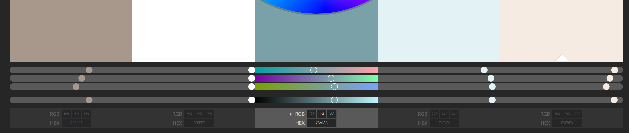**Color Scheme:** For the color scheme, I wanted to do cooler colors, and I didn’t want super bright colors. I will possibly even lighten the brown and turquoise color just a little bit

#A8988B

#F5EBE3

#E3F2F5

#7AA1A8

#FFFFFF